Compact, Wide-Band and Low Mutual Coupling MIMO Metamaterial Antenna using CPW Feeding for LTE/Wimax Applications
Duong Thi Thanh Tu^{1,2}, Nguyen Tuan Ngoc¹, and Vu Van Yem²
¹Faculty of Telecommunications 1, Posts and Telecommunications Institute of Technology
²School of Electronics and Telecommunications, Hanoi University of Science and Technology
Email: tudtt@ptit.edu.vn, nguyentuanngoc95bg@gmail.com, yem.vuvan@hust.edu.vn

Abstract - In this paper, a metamaterial antenna is designed by using coplanar wave (CPW) guide feeding to get wide-band and compact size. The Multiple Input Multiple Output (MIMO) antenna is constructed by placing side by side two single metamaterial antennas which are based on the modified composite right/left handed (CRLH) model. The proposed antenna covers the experimental-bandwidth of 22% for both case of single and MIMO antenna. Implementing in FR4 substrate with height of 1.6mm, the antenna gets compact in size with radiating patch dimension of 5.75x14mm² at 3.5GHz resonant frequency that is suitable for Long Term Evolution (LTE)/Wimax application in handheld devices. Furthermore, combining of Defected Ground Structure (DGS) and enlarged ground of coplanar structure has solved the challenge of mutual coupling between elements in the MIMO metamaterial antenna using CPW feeding. With distance of 0.46λ₀ from feeding point to feeding point, the MIMO antenna get high isolation of under -20dB for a huge bandwidth with a good agreement between simulation and measurement.
Keywords - MIMO, metamaterial, CPW, low mutual coupling, DGS.

1. Introduction
To satisfy high demands of users such as high data transfer rate, fast access, wireless communication technologies have been developed rapidly in recent years. One of these is MIMO technology which has attracted attention in terminals of modern wireless communication systems such as: 802.11n, 802.11ac, 802.11ad, 802.16m, LTE, LTE-advanced, and 5G. The most significant feature of MIMO is a high channel capacity increasing without bandwidth addition or transmission power increasing [1]. However, MIMO antenna systems demand a high isolation between antenna elements and a compact size for application in portable devices [2].
There are several techniques used to decrease the size of antenna, such as incorporating a shorting pin in a microstrip patch [3], using short-circuit [4], or cutting slots in radiating patch by fractal configuration [5]. Although it is interesting to figure that these methods have achieved quite impressed compact size, they face challenges of efficiency and gain reduction. Besides, using metamaterial is one of the methods that provides an opportunity to design an antenna with a small dimension with low cost and better performance parameters at both antenna and system [6], [7]. Using coplanar wave guide feeding, the metamaterial antenna is able to enlarge bandwidth [8].
Furthermore, coupling between the microstrip antennas is normally important in a MIMO system. Mutual coupling between antenna elements is an unwanted phenomenon that distorts the behavior of the radiating elements. In MIMO systems, each antenna affects other elements that are closely packed by radiating over the air or by propagating surface currents through the ground plane. Thus, performance of antennas tends to drop, especially for structure of MIMO metamaterial antenna. Many methods have been proposed to decrease mutual coupling between the antenna elements such as grooving dielectric, covering the patch by dielectric layers, or using shorting pins to cancel the capacitive polarization currents of the substrate. However, one technique is widely used in antenna design recently is metamaterial structures such as DGS and Electromagnetic Band Gap (EBG). These structures use the dielectric making a band gap structure between antenna elements hence the isolation between them is improved significantly. Despite this, the researches prefer to focus on suppressing element mutual coupling based on DGS techniques to EBG because they produce the band rejection characteristics similar to EBG structures but with a more compact size [9-10,12].
There are several researches about mutual coupling reduction of metamaterial MIMO antenna. The MIMO antenna in [11-13] get high isolation between antenna elements but distance from feeding point to feeding point rather long. In [14], the MIMO metamaterial antenna gets compact size and low mutual coupling of -45dB but the bandwidth has decreased significantly from 14.67% of single antenna down to 6.25% of MIMO. This is a challenge in design of MIMO metamaterial antenna using CPW feeding.
In this paper, a wide-band MIMO metamaterial antenna using CPW feeding is proposed. Based on FR4 substrate with the height of 1.6mm, the antenna gets compact radiating elements with patch size of 5.75x14mm² and operates at the frequency band of 3.1-3.8GHz. Using combination of DGS and enlarged ground of coplanar structure, the MIMO antenna gets low mutual coupling with distance of 0.46λ while ensuring 22% experimental bandwidth for both case of single and MIMO antenna.

2. THEORY AND DESIGN OF METAMATERIAL ANTENNA
An equivalent circuit model of fundamental composite right/left-handed transmission line (CRLH-TL) unit cell is presented in Fig.1. From this figure, the series capacitance (C_{L}) and the shunt inductance (L_{L}) as well as series inductance (L_{R}) and shunt capacitance (C_{R}) are determined in [6].
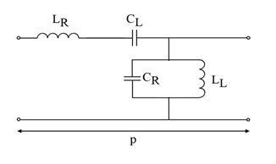
Fig.1 Equivalent circuit model of a CRLH-TL unit cell
The resonant frequency of antenna is calculated from equivalent circuit. By using Bloch-Floquet theorem for a CRLH-TL unit cell of periodic structures, the dispersion relation of the line is determined by the following formulas:
$$β(w)=\frac{1}{p}\cos^{-1}\left[1-\frac{1}{2}\left(\frac{w^{2}}{w_{R}^{2}}+\frac{w_{L}^{2}}{w^{2}}-\frac{w_{L}^{2}}{w_{se}^{2}}-\frac{w_{L}^{2}}{w_{sh}^{2}}\right)\right]$$ | (1)
where β is the propagation constant of Bloch wave, p is the physical length of the unit cell, and w is an angular velocity of metamaterial antenna which is a variable of β function, β(w).
$$w_{R}=1/{\sqrt{L_{R}C_{R}}}$$ | (2)
$$w_{L}=1/{\sqrt{L_{L}C_{L}}}$$ | (3)
$$w_{se}=1/{\sqrt{L_{R}C_{L}}}$$ | (4)
$$w_{sh}=1/{\sqrt{L_{L}C_{R}}}$$ | (5)
The resonant condition of the CRLH-TL is obtained by following condition [7]:
$${}_{n}p=\frac{nπp}{l}=\frac{nπ}{N}\left(n=0,±1,±2, …, ±(N-1)\right)$$ | (6)
where n, N, l are the resonant mode, number of unit cell, and the total length of the resonator, respectively. When n=0, the wavelength becomes infinite and the resonant frequency of zero mode (ZOR) becomes independent of the antenna size hence it can make the compact antenna.

2.1. Single Metamaterial Antenna.
The structure of the proposed antenna is illustrated in Fig.3 with the equivalent circuit is shown in Fig.2. The antenna is based on CRLH-TL and CPW feeding for reducing the size and getting wide band.
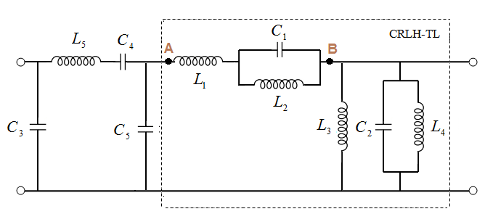
Fig. 2 Equivalent circuit of the proposed metamaterial antenna
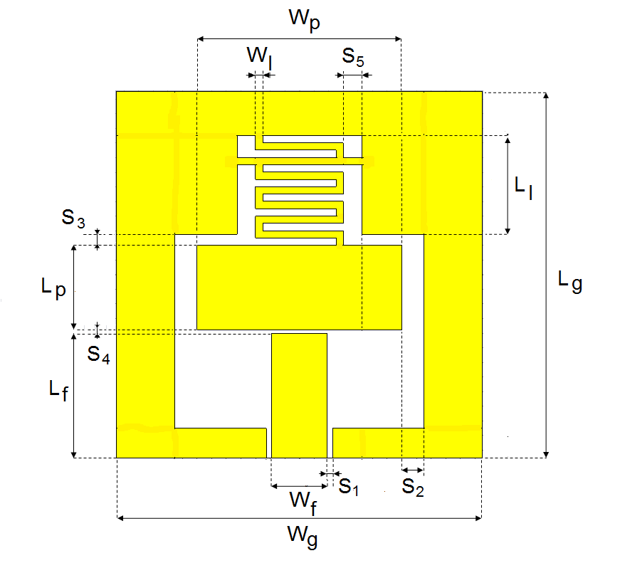
Fig.3 Configuration of the proposed CRLH-TL antenna
In this design, the inductance L₂ and capacitor C₁ are realized by larger part of meandered line while the C2 and L₄ are formed similar by smaller one. Inductance L₃ is realized by the line connecting the meander line to the ground. The radiation patch takes shape the inductance L₁. The C₃, C₄, and C₅ capacitor are formed between two strips separated by distance of S₁, S₄ and S₂, respectively. Impedance of AB circuit is obtained by following equation:
$$Z_{AB }=wL_{1}+\frac{wL_{2}}{1+w^{2 }L_{2}C_{1}}$$
$$=wL_{1}+\frac{1}{\frac{1}{wL_{2}}+wc_{1}}$$
$$=wL_{1}+\frac{1}{w(\frac{1}{w^{2}L_{2}}+C_{1})}$$
$$=wL_{R}+\frac{1}{wC_{L}}$$ | (7)
Thus, the series and shunt inductances L_{R}, L_{L} as well as the capacitor C_{R}, C_{L} are calculated by following equations:
$$L_{R}=L_{1}$$ | (8)
$$L_{L}=\frac{L_{3}L_{4}}{L_{3}+L_{4}}$$ | (9)
$$C_{R}=C_{2}$$ | (10)
$$C_{L}={\frac{1}{w^{2}L_{2}}+C}_{1}$$ | (11)
For operating at 3.5GHz, all detail dimensions of antenna are calculated and optimized by CST (Computer Simulation Technology) software and shown in Table 1. Using FR4 substrate with height of 1.6mm, dielectric constant of 4.4 and loss tangent of 0.02, the antenna gets compact radiation patch size of 5.75x14mm² which is quite suitable for LTE-A tablet or Wimax application.
Table 1. The geometry dimension of the proposed single antenna
Parameter | Value (mm) | Parameter | Value (mm)
L_{g} | 25 | L_{l} | 6.75
W_{p} | 14 | S₁ | 0.35
L_{p} | 5.75 | S₂ | 1.5
W_{f} | 3.8 | S₃ | 0.75
L_{f} | 8.5 | S₄ | 0.25
W_{l} | 0.5 | S₅ | 1.25

2.2. MIMO Antenna.
In classical array design, the distance between the elements has been kept to around 0.5λ to minimize unwanted coupling between the elements of an array and to minimize the spatial correlation. Here, we optimize this distance basing on simulation from 0.4λ to 0.5λ to estimate its effect to S parameters. Thus, our metamaterial MIMO model is constructed by placing two single antennas side by side at distance of 0.46λ₀ from feeding point to feeding point.
The layout of antenna is shown in Fig. 4 with total antenna size of 25x65mm². The performance of MIMO antenna using coplanar gets significantly decreased by the capacitor C which is formed between two strips separated by distance of antenna from edge to edge. To solve this problem, a combination of etching a novel DGS structure and an enlarging the ground of antenna on surface plane is proposed as illustrated in Fig.5.
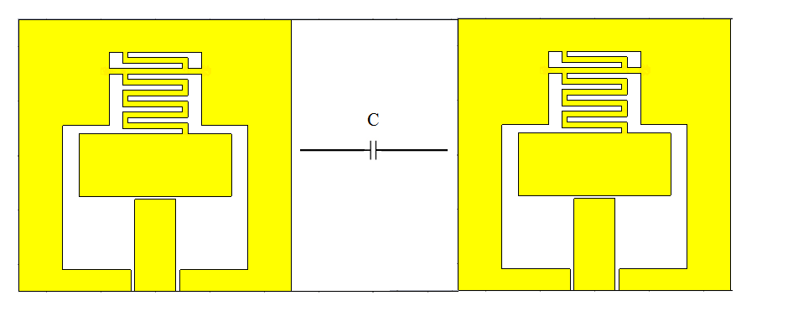
Fig. 4. Configuration of the metamaterial MIMO antenna
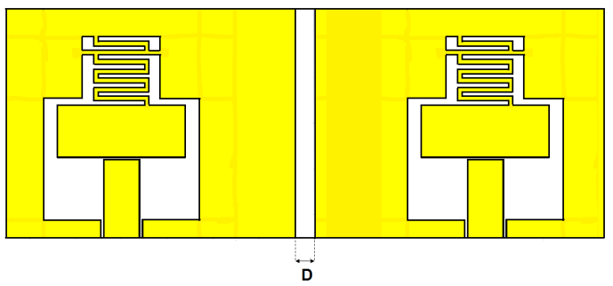
(a) Top plane
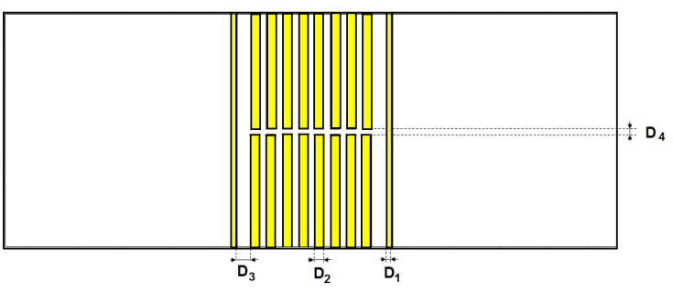
(b) Bottom plane
Fig. 5. Configuration of the proposed metamaterial MIMO antenna with etching DGS structure and enlarging ground on the surface
For decreasing the mutual coupling at 3.5GHz operating frequency over large band, detail dimensions of DGS structure as well as enlarging ground on the surface of MIMO antenna are optimized by CST software and shown in Table 2.
Table 2. The geometry dimension of MIMO antenna
Parameter | Value (mm)
D₁ | 0.5
D₂ | 1
D₃ | 1.5
D₄ | 0.5
D | 2

3. SIMULATION RESULTS

3.1. Single Antenna.
Simulation of prototype antenna using CST software is presented in this part. Current distributions of the metamaterial antenna at the center frequency of LTE/ Wimax application are exhibited in Fig. 6. As observed in this figure, the current distribution on antenna at 3.5 GHz mainly focuses on the meandered strips instead of on the radiating patch as the principle of microstrip antenna. Thus, the resonant frequency of the proposed metamaterial antenna depends on the dimensions which are contributed the CRLH structure such as S₃ and S₅.
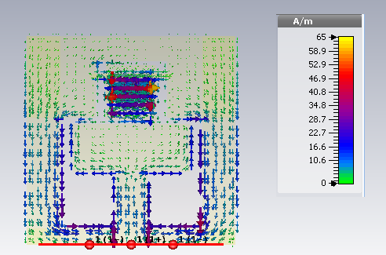
Fig. 6. Surface current distribution on single antenna
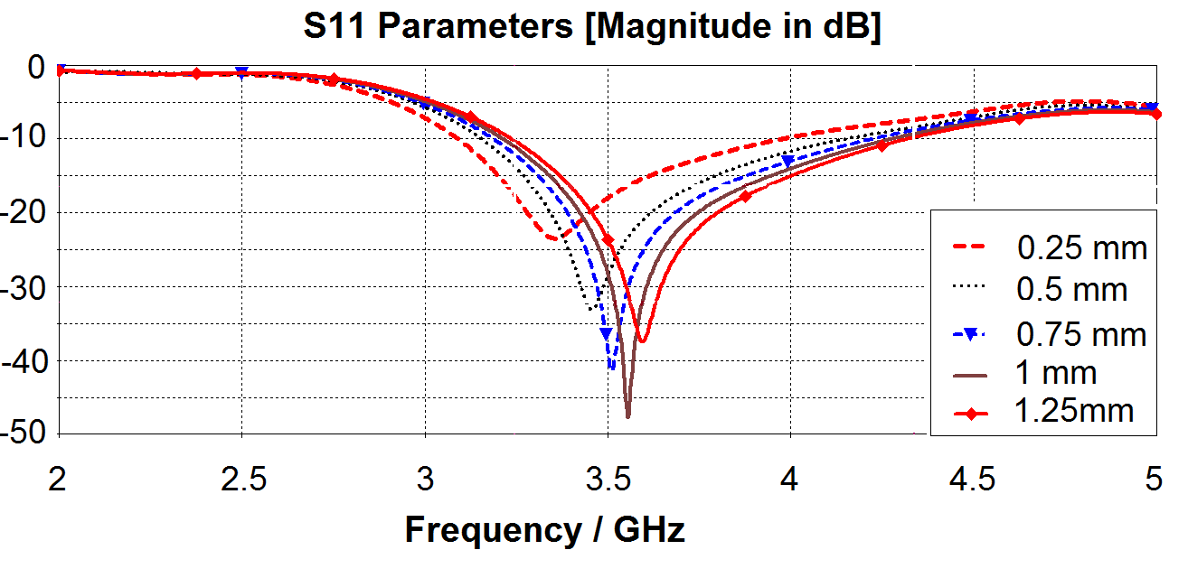
(a)
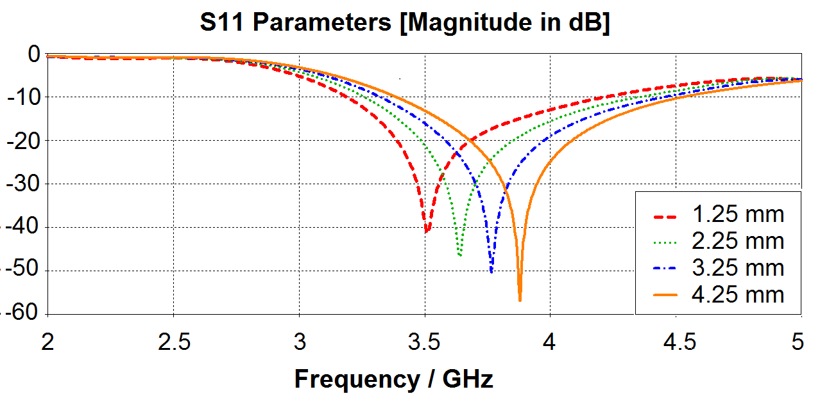
(b)
Fig. 7. S₁₁ results of single metamaterial antenna for different values of (a) S₃ and (b) S₅
Fig.7 illustrates the S₁₁ results of the single metamaterial antenna with different values S₃ and S₅. To get resonant frequency of 3.5GHz, all dimension of the proposed metamaterial antenna is optimized by CST software. The S parameter of single metamaterial antenna is shown in Fig.8. It is obvious that the antenna operates at 3.5GHz with a large bandwidth of 1.03GHz (29.4%). The reflection coefficient is -40dB at the resonant frequency.
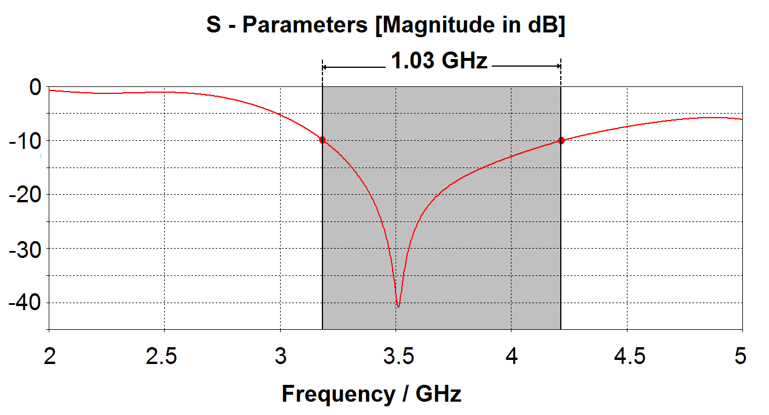
Fig. 8. S11 parameter of single metamaterial antenna
The 2D and 3D radiation patterns of the proposed antenna are illustrated in Fig. 9 that is suitable for handheld devices with dipolar and smooth radiation. Besides, the antenna radiation efficiency of 71% and gain of 1.96dB are rather good at 3.5GHz resonant frequency with dipolar radiation pattern [15].
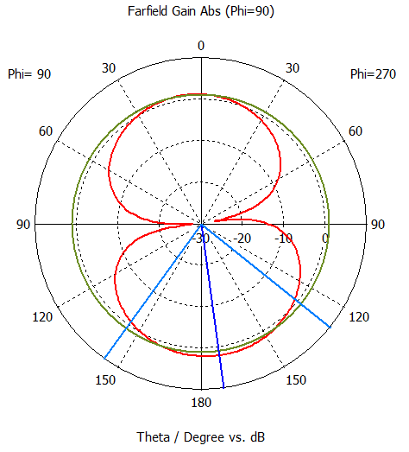 | 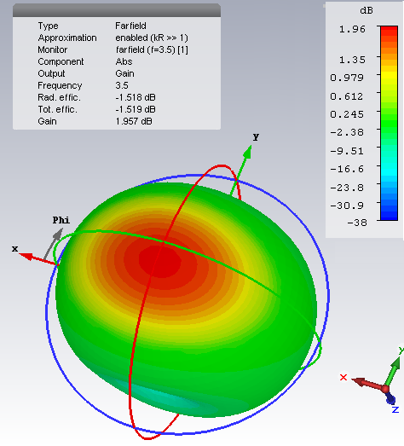
(a) 2D | (b) 3D
Fig. 9. The radiation pattern of single antenna
In addition, Table 3 shows comparison between our proposed antenna and the previous meta antenna designs. It is clearly seen that, the resonant frequency of all previous researches depend on ZOR and can not adjust to desired resonant frequency like our proposed antenna. Besides, the proposed antenna gets much larger bandwidth than all previous researches.
Table 3. Comparison between present design and previous single Meta antenna studies
 | [16] | [17] | [18] | [19] | [20] | Our design
Freq.  (GHz) | 5.55 | 1.94 | 2.1 | 2.14 | 8.45 | 3.5
Bandwidth  (%) | 4.3 | 10.3 | 15.1 | 7.84 | 22.9 | 29.4
Radiation Efficiency (%) | 75.6 | 85 | 72 | 81.7 | 74 | 71
S11(dB) | -32 | -25 | -32 | -25 | -30 | -40
Total size (λ²) | 0.63  x  0.74 | 0.18  x  0.32 | 0.14  x  0.22 | 0.18  x  0.15 | 0.22x 0.43 | 0.29  x  0.29
Gain (dBi) | 6.7 | 2.3 | 1.62 | 1.69 | 1.83 | 1.96

3.2. MIMO Antenna.
The simulation results of reflection coefficients of initial MIMO antenna (without DGS and enlarge ground) are shown in Fig. 10. From this figure, it is observed that the S parameters of initial MIMO antenna are changed and can not meet the isolation demand of MIMO antenna due to the effect of mutual coupling. In operation band, the S12 and S21 are not below -20dB.
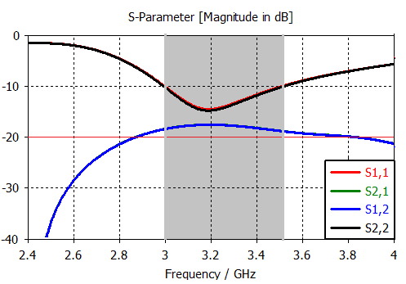
Fig. 10. Simulation S parameters of initial MIMO antenna
This fact is clearly demonstrated by surface current distribution on the initial MIMO antenna in Fig.11. It is observed from this figure that when the first antenna element is excited from Port1, the surface current is strongly induced on the second antenna element at Port2 therefore the mutual coupling (S12 and S21) are increased.
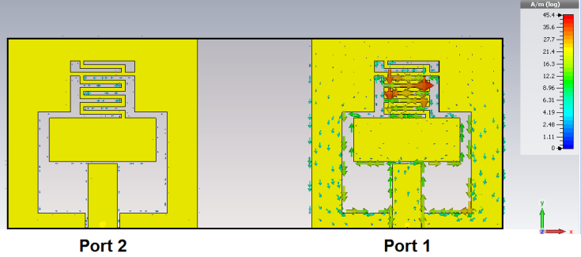
- Top plane
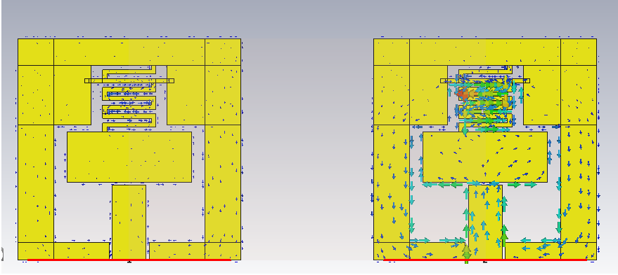
- Bottom plane
Fig. 11. Surface current distribution at 3.5 GHz on initial metamaterial MIMO antenna

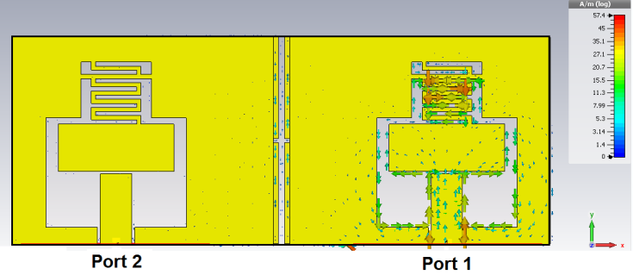
- Top plane
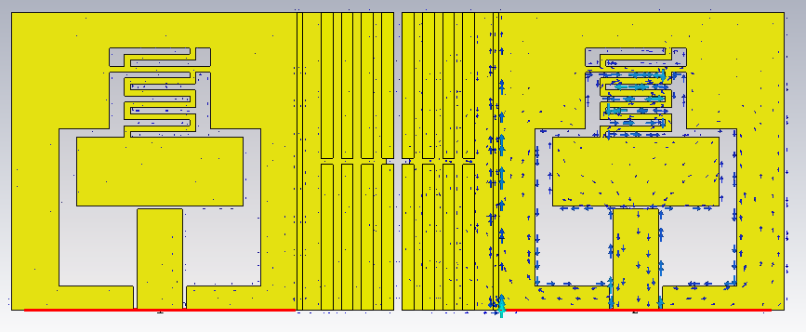
- Bottom plane
Fig. 12. Surface current distribution at 3.5 GHz on the proposed MIMO antenna with DGS and enlarging ground structure
To solve this challenge, a combination DGS and enlarge ground structure is proposed. The enlarge ground leads the surface current affecting DGS structure hence the current distribution of the proposed MIMO antenna at 3.5GHz is focused on the DGS structure as shown in Fig. 12. That is why the effect of the surface current from the first element to the second element is reduced as seen clearly in Fig. 13. The S12 is below -20dB all over the wide band. In addition, using combination DGS and enlarge ground structure is able to improve the reflection coefficient. The reflection coefficient is decreased by 25dB and gets -40dB at resonant frequency with enlarge bandwidth that compares to initial MIMO antenna.
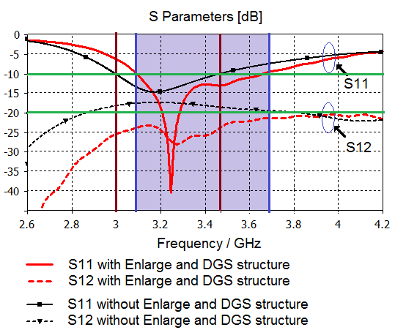
Fig. 13. The simulation S parameters of MIMO antenna
The 2D and 3D radiation pattern of the proposed MIMO model are shown in Fig. 14. By low mutual coupling between antenna elements, the radiation pattern shape of MIMO antenna is the same of single antenna. The gain is still good with dipolar radiation pattern.
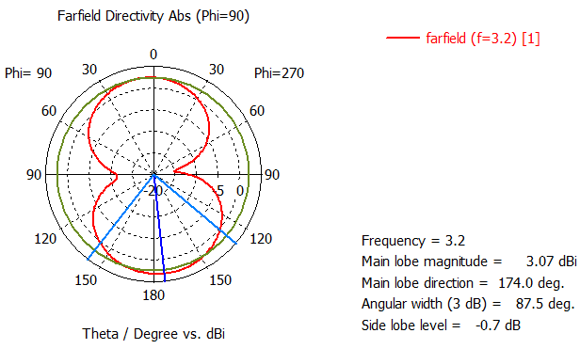
- 2D
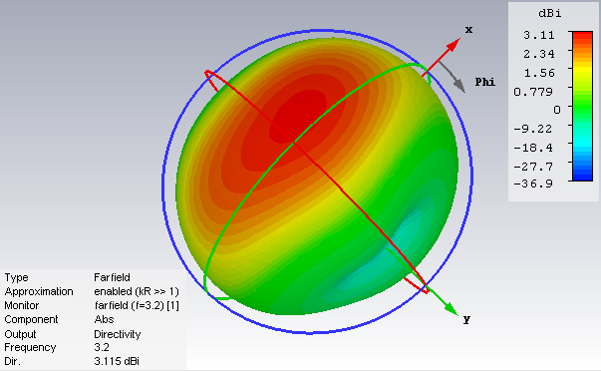
- 3D
Fig. 14. The radiation pattern of the proposed antenna
In MIMO antenna system, correlation factor, which is so-called enveloped correlation coefficient (ECC), will be significantly degraded with higher coupling levels. The factor is calculated from radiation patterns or scattering parameters. For a simple two-port network, assuming uniform multipath environment, the enveloped correlation ($ρ_{e}$), can be calculated conveniently and quickly from S-parameters, as follows [21]:
$$ρ_{e}=\frac{{\left|S_{11}^{*}S_{12}+S_{21}^{*}S_{22}\right|}^{2}}{\left(1-{\left|S_{11}\right|}^{2}-{\left|S_{21}\right|}^{2}\right)\left(1-{\left|S_{22}\right|}^{2}-{\left|S_{12}\right|}^{2}\right)}$$ | (12)
The correlation factor curves of proposed MIMO antenna at 3.5GHz are shown in Fig. 15. From this figure, the metamaterial MIMO antenna using combination DGS and enlarge ground structure has simulated ECC lower than 0.004 for all operation band. Therefore, it is quite suitable for mobile communication with a minimum acceptable correlation coefficient of 0.5 [22] as well as for LTE devices with value of |ρ_{e}| ≤ 0.3 for the bands of interest [23].
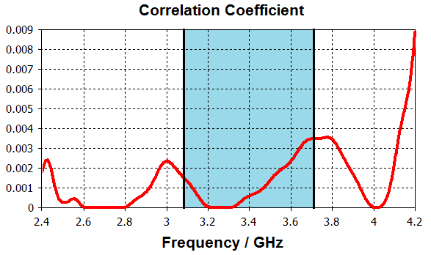
Fig. 15. Correlation Factor |ρ_{e}| curve for the proposed MIMO antenna

4. MEASUREMENT RESULTS
To verify the performance of the proposed metamaterial antenna, the antennas are fabricated with single and MIMO model on FR4 substrate with permittivity of 4.4 and the thickness of 1.6mm. Figure 16 shows photography of single antenna with total compact size of 25x25x1.6mm². The measurement result of S11 parameter is compared to simulation in Fig. 17. It is clearly seen that the single antenna operates at 3.5GHz with 22% bandwidth.
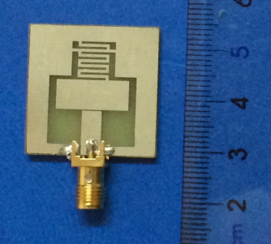 | 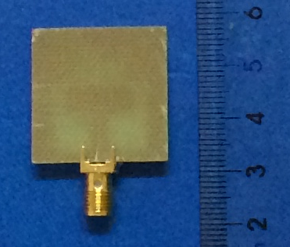
- Top plane | - Bottom plane
Fig. 16. Fabricated single antenna
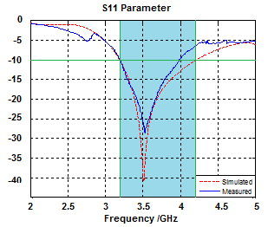
Fig. 17. Comparison between measurement result and simulation of S11 parameter of single antenna
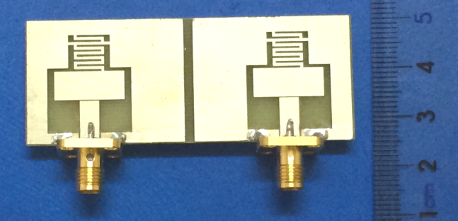
- Top plane
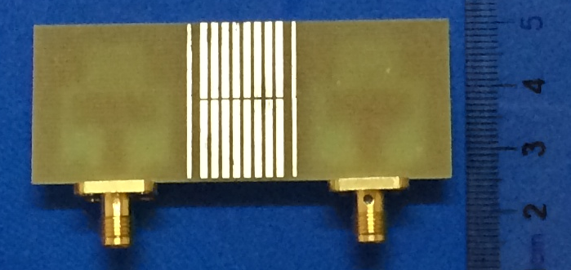
- Bottom plane
Fig. 18. Fabricated proposed MIMO metamaterial antenna using coplanar feeding
Figure 18 shows a photography of MIMO antenna with total compact size of 25x65x1.6mm². The measurement results of S parameters are compared to simulation ones in Fig. 19. It is observed that the MIMO antenna can also operate at 3.5GHz with 22% bandwidth.
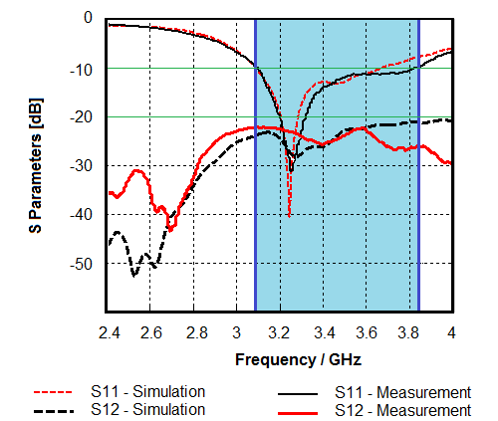
Fig. 19. Comparison between measurement and simulation result of S parameters of the proposed MIMO antenna
From this measurement, it can be concluded that the measurement results agree well with the simulation ones. Moreover, using combination of DGS structure and enlarged ground of coplanar structure, the MIMO antenna gets low mutual coupling with distance of 0.46λ while ensuring 22% experimental bandwidth for both case of single and MIMO antenna.

5. Conclusion
In this paper, the novel metamaterial antennas using CPW feeding are proposed. Based on CRLH-TL structure, the antennas get compact patch size of 30% comparison to conventional one. Thanks to combination of CRLH-TL structure and CPW feeding method, the proposed antenna gets large experimental bandwidth of 22% for both case of single and MIMO antenna. Moreover, for reducing the mutual coupling between patch elements in MIMO antenna, a combination of DGS structure and enlarge ground part on the surface plane is proposed. With high isolation for a large band of 600 MHz, the proposed structure of mutual coupling reduction is significant for wide-band commercial applications in modern wireless communication.

Acknowledgment
This work is partly supported by Motorola Solutions Foundation under Motorola scholarship and research funding program for ICT education.

REFERENCES
- G. J. Foschini and M. J. Gan, “On limits of wireless communications in a fading environment when using multiple antennas,” Wireless Pers. Commun., vol. 40, no.6, pp. 311-335, 1998.
- Shaikh AJ, Yusoff MZ, Yahya N., “Current issues and challenges of MIMO antenna designs.” 3rd International Conference on Intelligent and Advanced Systems (ICIAS2010), IEEE publisher, pp.1-5, June 2010.
- M.C. Huynh and W.Stutzman, “Ground plane effects on planar inverted-F antenna (PIFA) performance,” Microw. Antennas Propag., vol. 4, no.11, pp.209-213, Aug. 2003.
- M.C. Scardelletti, G.E. Ponchak, S.Merritt, J.S.Minor, and C.A.Zorman, “Electrically small folded slot antenna utilizing capacitive loaded slot lines,” 2008 IEEE Radio and Wireless Symposium, pp. 731-734, 2008.
- F. Merli; L. Bolomey; J. Zurcher; G. Corradini; E. Meurville and A. K. Skrivervik, “Design, realization and measurements of a miniature antenna for implantable wireless communiaction system,” Antenna Propag. IEEE Trans. On, vol. 59, no. 10, pp.3544 - 3555, 2011.
- Caloz, C., Itoh, T. “Electromagnetic metamaterials: transmition line theory and microwave applications,” Wiley, New York, 2006.
- Engheta, N., Ziolkowski, R. W., “Metamaterials: physic and engineering explorations,” Wiley, New York, 2006.
- Rainee N. Simon, “Coplanar Waveguide: circuits, components, and systems,” Wiley, New York, 2001.
- S. Xiao, M.-C. Tang, Y.-Y. Bai, S. Gao, B.-Z. Wang, “Mutual coupling suppression in microstrip array using defect ground structure,” IET Microwaves, Antennas & Propagation, Vol. 5, Issue 12, pp. 1488 - 1494, September 2011.
- F.-G. Zhu, J.-D. Xu, Q. Xu, “Reduction of mutual coupling between closely packed antenna elements using defected ground structure,” Electronics Letters, Vol. 45, Issue 12, p. 601 - 602, June 2009.
- J. Chanderasekhar Rao and N. Venkateswara Rao, “CPW-Fed Compact Ultra Wideband MIMO Antenna for Portable Devices,” India Journal of Science and Technology, vol.9, pp.1-9, May 2016.
- Nguyen Khac Kiem, Huynh Nguyen Bao Phuong, Quang Ngoc Hieu and Dao Ngoc Chien, “A Novel Metameterial MIMO Antenna with High Isolation for WLAN Application,” International Journal of Antenna and propagation, Volume 2015, Article ID 851904, 9pages, 2015.
- Mahmoud A. Abdalla, Ahmed A. Ibrahim, “Design of Close, Compact, and High Isolation Metamaterial MIMO Antennas,” Antenna and Propagation Society International Symposium, IEEE publisher, pp.186-187, 2013.
- Yalda Torabi, Ali Bahri, and Ali-Reza Shafiri, “A Novel Metamaterial MIMO Antenna with Improved Isolation and Compact size Based on LSRR Resonator.”, IETE Journal and Research, October 2015.
- ETSI TS 136 101 V10.3.0 (2011-06), “LTE, User Equipment (UE) radio transmission and reception,” 2011.
- Xue Li, Quan-Yuan Feng, and Qian-Yin Xiang, “A Novel via Less Resonant Type Antenna Based on Composite Right/Left Handed Trasmission Line (CRLH-TL) Unit Cell with Defected Ground Structure,” Progress In Electromagnetics Research Letters, Vol. 38, pp.55-64, 2013.
- Po-Wei Chen and Fu-Chiarng Chen, “Asymmetric Coplanar Waveguide (ACPW)Zeroth-Order Resonant (ZOR) Antenna WithHigh Efficiency and Bandwidth Enhancement,” IEEE Antennas and Wireless Propagation Letters, vol.11, 2012.
- Pei-Ling Chi, Member, IEEE, and Yi-Sen Shih, “Compact and Bandwidth-Enhanced Zeroth-Order Resonant Antenna,” IEEE Antennas and Wireless Propagation Letters, pp.1-4, 2015.
- Sheeja K.L., P.K.Sahu, S.K.Behera, “Comparative Study of a CRLH TL Based Zeroth Order Resonant Antenna,” N CC Conference, IEEE publisher, 2012.
- Muhammad Tauseef Asim, andMushtaq Ahmed, “Metamaterial Inspired Microstrip Antenna Investigations Using Metascreens,” International Journal of Antennas and Propagation Volume 2015, Article ID 236136, 9 pages.
- A. Lai, K.M.K.H. Leong, and T.Itoh, “Infinitive Wavelength Resonant Antennas with Monopolar Radiation Pattern Based on Periodic Structures,” IEEE Trans. Antennas Propag., vol.55, no.3, pp.868-876, Mar 2007.
- M. P. Karaboikis, V. C. Papamichael, G. F. Tsachtsiris, and V. T. Makios, "Integrating compact printed antennas onto small diversity/MIMO terminals," IEEE Transactions on Antennas and Propagation, vol. 56, pp. 2067-2078, 2008.
- 3GPP TS 36.101, V8.3.0. “EUTRA User Equipment Radio Transmission and Reception,” September 2008.

AUTHORS’ BIOGRAPHIES

Duong Thi Thanh Tu received B.E, M.E degrees in Electronics and Telecommunications from Hanoi University of Science and Technology and National University in 1999 and 2005, respectively. She now is a lecturer at Faculty of Telecommunications 1, Posts and Telecommunications Institute of Technology. She presently is doing PhD at School of Electronics and Telecommunications, Hanoi University of Science and Technology. Her research interests include antenna design for next generation wireless networks as well as the special structure of material such as metamaterial, electromagnetic band gap structure.


Nguyen Tuan Ngoc is a fifth student at Faculty of Telecommunications 1, Posts and Telecommunications Institute of Technology. Besides, he is also a part time collaborator at Viettel Network Technologies Center – VTTEK. His current research centers on antenna design for new generation wireless networks.


Vu Van Yem received PhD degree from the Department of Electronics and Communications, TELECOM ParisTech, France, in 2005. From 2006 to 2007, he was a postdoctoral researcher at the Department of Hyper-Frequency, the Institute of Electronics and Microelectronics and Nano technology (IEMN), France. He has been qualified as associate professor since 2009. He is the Head of the Department of Telecommunication Systems, School of Electronics and Telecommunications as well as Vice-Dean of Graduate School, Hanoi University of Science and Technology, Vietnam. His research interests are microwave engineering, antenna, chaos-based digital communications as well as advanced wireless communication and localization systems.

